
NON DOMESTIC PLANT COMMISSIONING/SERVICING RECORD
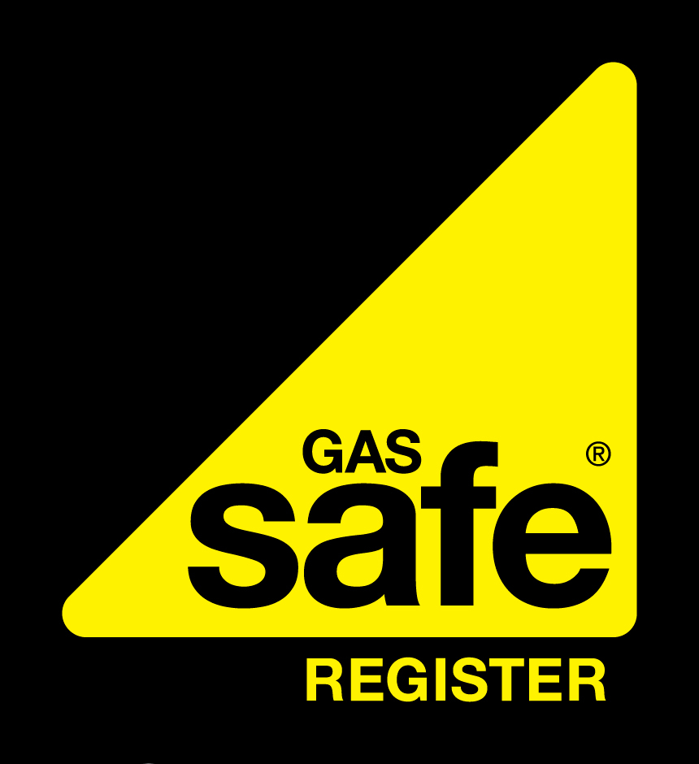
To confirm the validity of the Registered Gas Engineer please contact Gas Safe on 0800 408 5577 or www.gassaferegister.co.uk
COMPANY NAME  Gas Safe Reg No: 000000  W: WEB E: EMAIL  Job Number: | CLIENT DETAILS
 | Name:
 | Address:
 | Postcode:
 | Date:
APPLIANCE SPECIFICS
 | Appliance 1 |  |  |  |  | Appliance 2 |  |  |  |  |  |  | Appliance 3 |  |  |  |  |  | Appliance 4
Asset Number
Location of appliance
Appliance type
Appliance make
Appliance model
Type of flue/outlet
COMBUSTION
 |  | Appliance 1 |  |  |  |  |  | Appliance 2 |  |  |  |  |  | Appliance 3 |  |  |  |  |  | Appliance 4
Firing Mode |  | LOW |  |  | HIGH |  |  | LOW |  |  | HIGH |  |  | LOW |  |  | HIGH |  |  | LOW |  | HIGH
State heat input rating (kW)
Burner pressure (mbar)
Rate of gas (m³/hr)
Flue gas temperature (°C)
Temperature of room (°C)
Flue gas temperature (NET) (°C)
Draught pressure of flue
What is the Oxygen %? (O₂)
Carbon Monoxide (CO) ppm
What is the Carbon Dioxide %? (CO₂)
NO_{x} %
Excess air %
State the CO/CO₂ ratio
CO flue dilution ppm
What is the gross efficiency %
EXTRA CHECKS UNDERTAKEN |  | Appliance 1 |  |  |  |  |  | Appliance 2 |  |  |  |  |  | Appliance 3 |  |  |  |  |  | Appliance 4
Is there adequate ventilation? |  | Yes |  |  | No |  |  | Yes |  |  | No |  |  | Yes |  |  | No |  |  | Yes |  | No
Acceptable spillage test? |  | Yes |  |  | No |  |  | Yes |  |  | No |  |  | Yes |  |  | No |  |  | Yes |  | No
Was the flue flow test satisfactory? |  | Yes |  |  | No |  |  | Yes |  |  | No |  |  | Yes |  |  | No |  |  | Yes |  | No
Is the Air/gas pressure switch working? |  | Yes |  |  | No |  |  | Yes |  |  | No |  |  | Yes |  |  | No |  |  | Yes |  | No
Are Safety device(s) working? |  | Yes |  |  | No |  |  | Yes |  |  | No |  |  | Yes |  |  | No |  |  | Yes |  | No
What is the burner lock out time (seconds)?
Are temperature thermostats working? |  | Yes |  |  | No |  |  | Yes |  |  | No |  |  | Yes |  |  | No |  |  | Yes |  | No
Are limit thermostats working? |  | Yes |  |  | No |  |  | Yes |  |  | No |  |  | Yes |  |  | No |  |  | Yes |  | No
Has the appliance been serviced? |  | Yes |  |  | No |  |  | Yes |  |  | No |  |  | Yes |  |  | No |  |  | Yes |  | No
STANDARD SAFETY CHECKS
Is the gas compressor/booster working correctly? |  |  |  |  |  |  |  |  | Has a gas tightness test been undertaken?
Is the installation adequately sleeved and labelled? |  |  |  |  |  |  |  |  | Is the installation pipework sufficiently supported ?
Has the chimney system been installed to current standards? |  |  |  |  |  |  |  |  | Is the outlet termination adequate?
NATURAL VENTILATION |  |  |  |  |  |  |  |  | MECHANICAL VENTILATION
Room/Boiler lower level free area (cm²) |  |  |  |  |  |  |  |  | Mechanical flow rate inlet (m³/s)
Room/Boiler higher level free area (cm²) |  |  |  |  |  |  |  |  | Mechanical flow rate extract (m³/s)
Is ventilation adequate? |  |  |  |  |  |  |  |  | Is ventilation adequate?
LIST WORK UNDERTAKEN |  |  |  |  |  |  |  |  | LIST REMEDIAL WORK NEEDED
Has a Warning/Advice Notice been issued? Y/N |  |  |  | Have Warning Labels been attached? Y/N |  |  |  |  |  |  |  |  |  |  | Has a responsible person been advised? Y/N

Engineer | Name | Signature

